Earth 231: Mineralogy
Bancroft Group Project
Topic: Skarn
Group number: 9

Instructions: Please fill out the following table and indicate what part of the paper you wrote/created, what part of the paper you have helped to edit, and what part of the paper you have read. I’ve included a few examples in the table.
Also, by listing your name, you are acknowledging the following statement:

This assignment as submitted reflects the level of understanding of all students whose names appear below. Further, we declare that our assignment is free from violations of academic integrity. If it is discovered that any assignment contains material that constitutes a violation of academic integrity, we recognize that we are all equally responsible and will be subject to disciplinary action consistent with University Policy

Name | Wrote /Created | Edited | Read
- Harry Barnes (#20983410) | - Local Geologic map  - Some of local geology section  - Outcrop rock description  - Outcrop map  - Geological history (of the outcrop specifically) | - Abstract (to include outcrop-specific info) | - N/A
- Noel Campfens (#20837974) | - Abstract  - Skarn formation overview and formation processes  - Conclusion | - N/A | - All sections (in order to complete abstract and conclusion)
- Arman Kanorwalla (#20899832) | - Geologic history of the Grenville province  - History of our outcrop | - N/A | - Skarn review (in order to interpret the outcrops history)  - At the out crop
- Blue Ketchum (#20874430) | - Part of local geology section  - Regional geology/the Grenville Province  - (Both to be handed in at a later date) | - N/A | - N/A

Abstract

The Grenville province is home to many interesting geologic rocks and the history of the processes that created them. One of these interesting minerals is skarn, which is a metamorphic rock formed by regional/contact metamorphism or metasomatism. Metasomatism is a process by which a magma body intrudes a sedimentary or igneous rock and by way of heating and cooling the minerals changes the inherent composition of the rock itself. Skarn can be mined for many important economic minerals such as gold, copper, and silver due to the dissolved metal ions that enter the rock through the process of metasomatism. The skarn rocks that we examine in this paper are located in the Grenville province. The Grenville province is the youngest of the Canadian shield's geologic provinces. The geologic history of Grenville is exceedingly difficult to decipher due to the extreme metamorphism, and it was not until the proposal of plate tectonic theory could scientists create a model for the history of the province. The province is no known for undergoing extreme amounts of changes, specifically orogeny's (such as the Elzevirian Orogeny and the Ottawan Orogeny). Our outcrop itself is located within the Grenville Province at 44°54'57.4"N 78°04'38.4"W, and in this paper, its geology and the processes that aided in its formation will be outlined. There were various rock units found in the outcrop were granite, marble, tremolite, wollastonite, as well as phlogopite was found in all rock units. These units and their compositions were determined using a variety of factors such as lustre, cleavage and hardness etc. From this information, where these different units started and finished was able to be determined and an outcrop map was then constructed showing where this specific units existed in the outcrop. The geologic history of the outcrop is vast. It is the footprint of the last tectonic event to shape the Canadian shield, spanning from the Paleoproterozoic from the Mesoproterozoic era. Our skarn sample is formed in the metasedimentary belt which can be accounted for by rifting and thrusting from the Amazonia collision. We can see that the skarn is made from calcite due to the effervescence with dilute acid. During the entirety of the Grenvillian period, metamorphism and deformation were very widespread events that occurred throughout the entirety of the province.

Skarn review

Skarn is a metamorphic rock that has undergone metasomatism which changes the mineral chemically and mineralogically. (Meinert 1992) The process of metasomatism as defined by generally defined as: “metamorphism which involves a change in the chemical composition excluding the volatile components” (Putnis et al.,2010).

Skarn deposits also form from regional or contact metamorphism and other metasomatic processes as described above. Skarn deposits are found next to plutons, faults and other shear zones, the seafloor, and low geothermal systems. Skarns are also found on every continent on earth and any aged rock. They are mined for elements such as iron, Copper, lead, zinc, molybdenum, silver, gold, uranium, boron, tin, and tungsten. (Meinert, 1992). The mineralogy which has a large array of calcium-silicate minerals but is monopolized by garnet and pyroxene. Because of this, when skarn is present, this does not indicate any particular geologic setting or composition. What it means instead is that the temperature, pressure, fluid, and host rock composition was within the range of stability for the skarn minerals (Meinert, 1992).

Metasomatism requires a fluid phase to occur, generally as a magmatic body intrudes a rock. The major difference between metasomatism and metamorphism is that metasomatism requires an external fluid source to change the composition of a rock which then reequilibrates as opposed to metamorphism which is a rock that reequilibrates as a response to purely pressure and temperature (Putnis et al.,2010). These fluids can come from magmatic, metamorphic, and meteoric/marine origin. (Meinert, 1992) these fluids are the transport mechanisms for the induction of reequilibriation through dissolution of the starting phases and reprecipitation of new products within the rock that then change the composition of the parent rock changing it into skarn which now is calcium silicate-silicate rich. (Putnis et al.,2010)

Regional geology – the Grenville Province

[Blue to complete this section]

Local geology

It is important to consider the geology surrounding the outcrop to understand the broader context and the processes that may have impacted the formation of the outcrop. As demonstrated in our geological map (Figure 1), the outcrop is surrounded by an area of dolomitic marble which is wedged between belts of mafic metavolcanic rocks and amphibole-rich metasedimentary rocks. The outcrop also lies on a geologic fault, which may have some impacts upon the type of rocks found at our outcrop and the processes which formed them.

[Blue to complete the rest of this section]

At the outcrop

Figure 2 depicts our geological outcrop map. We were able to divide the rocks that we found at our outcrop into two key units: granite and marble. We determined that the first rock unit was granite, due to its constituent minerals, such as K-feldspar and quartz – identified through their physical properties such as color (and hardness in the case of quartz, which was determined to be 7). There were also pyroxene crystals within the granite, further indicating the igneous origins of this intrusion as evident in figure 3 (Earle, 2019 The two main granite intrusions found at the outcrop are labelled as category ‘1’ on the geologic outcrop map.

The next major rock unit – marble – was significantly more diverse and complex, varying to a significant extent in composition and constituent minerals. As such, this rock unit was further divided up into sub-units: marble that was calcitic, and marble that rich in phlogopite, tremolite, wollastonite, and both wollastonite and tremolite as 2a, 2b, 2c, 2d, and 2e, respectively. While there were some deviations to these subdivisions, the subdivision they were classified to best fit the dominant mineral (alongside the typical minerals one would expect to find within marble) that were constituent within the rock. When determining these classifications, we once again considered the minerals found in each unit. The marble that was primarily calcitic tended to have a more basic composition, with lower amounts of the mineral’s characteristic of a skarn environment.

We determined that rock unit 2a (Figure 4) was calcitic marble as it prominently features calcite within its composition, as determined by its effervescence with dilute hydrochloric acid, this mineral’s hardness of 3 on Moh’s scale of hardness, and its 3 cleavage planes (all at 75 degrees).

Tremolite (Figure 5) was easily identified due to its distinctly fibrous lustre as well as its cleavage, of which there are two planes at 60 and 120 degrees.

Wollastonite (Figure 6) was identified less easily, however, it also has characteristic cleavage and hardness - in this case, 2 planes at 90 degrees and a hardness of 5.

Phlogopite was found in all marble rock units, however, was specifically prominent in unit 2b. It was identified due to its vitreous lustre that appears sparkly due to its small silver-brown crystals. This identification was further reinforced by its cleavage and hardness, of which the mineral had one perfect plane and a low hardness of 2.5, strongly suggesting it belongs to the mica category. As it was rich in magnesium, it was determined that this mineral was indeed phlogopite.

Between the granite and marble rock units themselves is a contact, which can be seen prominently in figure 7, with a rather abrupt shift in rock composition. This can be further investigated by identifying the minerals within the two varying compositions, to find that in the rock unit on the left, there was a large concentration of typically igneous minerals such as potassium feldspar, determined by its hardness of 5.5 and 2 cleavage planes at right angles (also further indicated by the orange-pink color of the rock). While the rock unit on the left was rich in calcite (as determined by the hardness of 3, and its 3 cleavage planes at 75 degrees). Because the change between the rock units is so abrupt, it strongly suggests that this contact is the result of an intrusion by the granite, suggesting that the marble was metamorphosed from a previously limestone-rich environment.

Geological history

As touched on prior to this, the visual evidence at the outcrop indicates how the outcrop came to be. The sudden shift in rock composition at the contact between the marble and the granite rock types (Figure 7) suggests that the granite originated from a plutonic intrusion with metasomatic fluids and metamorphosed the previously limestone-rich environment into marble, with the crystallization of the minerals within these fluids forming the distinct minerals wollastonite and tremolite that are found within this outcrop. Additionally, it is also necessary to consider the broader geological context of the local area, especially the geologic fault that runs alongside the outcrop. This paves the way for such plutonic intrusions to occur (Román-Berdiel et al., 1997), as provides an explanation for the skarn to form in the way that it does.

Historically the Grenville Province is said to represent the footprint of the last tectonic event to shape the Canadian Shield. The Grenville’s location along the eastern margin of the Laurentia continent has contributed greatly to its history and formation. Its history spans mainly over Paleoproterozoic to Mesoproterozoic eras and can be further sub divided into events that took place during these eras.

The following events show the chronological history of the Grenville province:

· Prelabradorian Orogenesis (1900-1710 Ma)

The Prelabradorian spanned over a period of 200 million years. The study of sulphur isotopes on these paragneiss has given us an estimation of the Proterozoic age of the rocks found in this region (Wing et al., 2012). During the Prelabradorian a series of accretional orogeneses affected the Laurentia continent. These were the Penokean, Makkovikian and Ketilidian orogeneses (Gower and Krogh, 2002, 2003).

· Labradorian Event (~1710 and 1600 Ma)

A period of approximately 110 million years is covered by the Labradorian event and can be confirmed by the observation of plutonic intrusions from this period in eastern Quebec. These plutonic intrusions include the Deep Cove Megacristic Granite and Mealy Mountains Intrusive Suite (Gower, 1996). During this period a continental-marginal basin was created and subsequently destroyed during accretion of a magmatic arc formed over a south-dipping subduction zone. This subduction was short-lived and arrested, leading to the formation of a passive continental margin. (Gower and Krogh, 2002, 2003)

· Wakamian Event (1600-1520 Ma)

The Wakehamian event covers a period of 80 million years and has been established to correspond to a deposition event in a back-arc basin (Gobeil et al. 2003). The central part of the grenville recognised magmatic activity that saw intrusion of the Outardes Plutonic Suite (Moukhsil et al., 2011, 2012)

· Pinwarian Orogenesis (1520-1450 Ma)

The Pinwarian Orogenesis takes place a period of 70 million years and can be seen extending throughout the Grenville Province. The Pinwarian is interpreted as the result of continental margin arc magmatism that corresponds to a magmatism and sedimentation episode in the central part of Grenville, while it is predominantly magmatic elsewhere in Grenville. Due to the large volume of plutonic rocks in found in this period it can easily be classified to be one of the most important orogeneses in the Grenville Province. (Gower and Krogh, 2002).

· Elsonian Event (1450-1230 Ma)

The Elsonian is the longest event in the Grenville orogenesis. This episode can be characterized primarily by the intrusion of anorthosite-mangerite-charnockite-granite suites associated with troctolites, gabbros and quartz monzonites (Stockwell, 1964). Since the Elsonian event takes place over such a large amount of time it can be further sub divided into three subperiods: Early Elsonian (1450-1350 Ma); Mid Elsonian (1350-1290 Ma); and Late Elsonian (1290-1230 Ma). (Gower and Krogh, 2002).

· Elzevirian Orogenesis (1230-1180 Ma)

It was determined that compression resumed with the Elzevirian accretional orogenesis and that during this period the Central Metasedimentary Belt accreted to the Laurentia continent to develop in an arc environment (Gower and Krogh, 2002). During the Elzevirian Orogeny substantial volumes of juvenile calc-alkaline crust were added to the northwest segment of the Central Metasedimentary Belt (McLelland et al.,1996)

· Adirondian Event (1180-1080 Ma)

The Andirondion period takes place over a span of 100 million years and has been characterised by their large volume intrusions of large-scale anorthositic suites throughout the Grenville Province in a back-arc basin during a crustal extension event. (Gower and Krogh, 2002).

· Grenvillian Orogenesis (1080-985 Ma)

The Grenvillian orogenesis can be characterized by large-scale magmatism and intense deformation, accompanied by prograde metamorphism of the Grenville province. This event took place over a span of 100 million years. It represents the deep roots of an ancient mountain range whose size was comparable to the Himalayas. (Gower and Krogh, 2002). There are 2 major pulsations of crustal shortening that took place during this period (Rivers et al, 20120. These pulsations also took place in the central part of grenville but at a much different time than the other area. The Grenvillian Orogenesis can be subdivided into three periods (Gower and Krogh, 2002):

1. Early Grenville (1080-1050 Ma).
2. Mid Grenville (1050-1018 Ma).
3. Late Grenville (1018-985 Ma).

History of our outcrop

Our outcrop is mainly composed of rocks that date back to the Late Elsonian (1290-1230 Ma) to the Elzevirian period (1230-1180 Ma). Hence it is most likely that the sedmiments were deposited during this period. We can see that substantial volumes of juvenile calc-alkaline crust were added to the northwest segment of the Central Metasedimentary Belt during this period (McLelland et al.,1996). Since our out crop is mainly composed of calcite (tested by dil. HCl being poured on it) we can interpret that the sediment deposited in the Elzevirian period are most likely the sediments are most likely the sediment that form our outcrop. We also see the presence of Tremolite, Wollastonite & Phlogopite in our out crop which could be from the calc-alkaline crust deposit. We also see the presence of granite which would have come much later than our sediment through intrusions and would have caused the sediments to metasomatise. The metasomatism must have taken place during the Grenvillian Orogenesis (1080-985 Ma) as there was a large amount of regional metamorphism present during this time.

Conclusions

There are a variety of diverse types of skarns and how they form all over the world by processes such as metasomatism and contact/regional metamorphism. It is important to understand the major difference between metamorphism and metasomatism is a process that requires an external source of fluids in order to change the composition of the rock whereas metamorphism requires only temperature and pressure to reequilibriate the rocks. In our outcrop specifically, there are a variety of skarns such as tremolite skarn and wollastonite as well as granite and marble being present in the outcrop. This was determined from a multitude of factors chiefly hardness and cleavage as well as other features used in determining mineral composition such as lustre. Using these factors to determine the different compositions of the outcrop as well as where these different units start and finish, an outcrop map was able to be created from this information. The geological history of the Grenville province can also aid in how our outcrop came to be. The sudden shift in composition indicates a plutonic intrusion to form the wollastonite and tremolite in the skarn. The history of the Grenville spans an extended period of time from the Paleoproterozoic from the Mesoproterozoic era. Many orogenies and major geologic events took place within the Grenville province to give it the geology that it currently has. These events have left a footprint in the form or several types of rocks such as various types of skarns, that we have viewed and identified in our outcrop.

Reference list
Earle, S., & Panchuk, K. (2019). Physical geology (2nd ed.). BCcampus.

Earth 231 LEARN content, photo SKAR 1, SKAR 6, SKAR 11, SKAR 13, SKAR 17, Fall 2021

Gobeil, A., Brisebois, D., Clark, T., Verpaelst, P., Madore, L., Wodicka, N., Chevé, S. (2003) Géologie de la moyenne Côte-Nord, Dans: Géologie et ressources minérales de la partie est de la Province de Grenville; Daniel Brisebois et Thomas Clark coordonnateurs. Ministère des Ressources naturelles, Québec; DV 2002-03, pages 9-58.

Gower, C.F., Krogh, T.E. (2002) A U-Pb geochronological review of the Proterozoic history of the eastern Grenville Province. Canadian Journal of Earth Sciences; volume 39.

Gower, C.F (1996). The evolution of the Grenville Province in eastern Labrador, Canada. In: Brewer, T.S., editor. Precambrian Crustal Evolution in the North Atlantic Region, Geological Society Special Publication; 112. Geological Society Publishing House, Bath, UK

Lumbers, S.B., and Vertolli, V.M (2000) Precambrian geology, Gooderham area. Ontario Geological Survey, Preliminary Map P.3405, scale 1:50,000.

Meinert, L. D. (1992). Skarns and Skarn Deposits. Geoscience Canada,19(4).

Moukhsil, A., Lacoste, P., Solgadi, F., David, J. (2011). Géologie de la partie orientale de la région de Baie-Comeau (partie ouest de 22G). Ministère des Ressources naturelles et de la Faune, Québec; RG 2011-02, 33 pages, 1 plan.

Putnis, A., & Austrheim, H. (2010). Fluid-induced processes: Metasomatism and metamorphism. Geofluids. doi:10.1111/j.1468-8123.2010. 00285.x

Rivers,T., Culshaw, N., Hynes, A., Indares, A., Jamieson, R., Martignole, J. (2012) The Grenville orogen – A post-LITHOPROBE perspective. Chapter 3. In: Tectonic Styles in Canada: The LITHOPROBE Perspective. Edited by J.A. Percival, F.A. Cook and R.M. Clowes. Geological Association of Canada; Special Paper 49, pages 97-236.

Roman Berdiel, T., Gapais, D., & Brun, J.-P. (1997). Granite intrusion along strike-slip zones in experiment and nature. American Journal of Science, 297(6), 651–678. https://doi.org/10.2475/ajs.297.6.651

Stockwell, C.H. (1964). Age determinations and geological studies. Part II: Geological studies; Fourth Report on Structural Provinces, Orogenies, and Time-Classification of Rocks of the Canadian Precambrian Shield. Geological Survey of Canada; Paper 64-17, 35 pages, 2 plans

Appendices
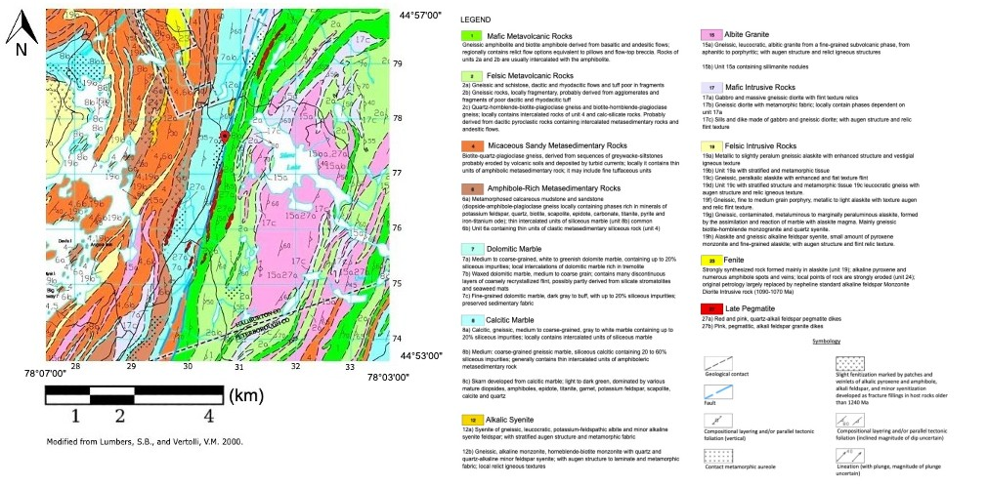
Figure 1: Our updated geological map, with the outcrop of study at the location indicated by the dropped pin at 44°54'57.4"N 78°04'38.4"W, 25738 ON-28, Harcourt, Ontario (Modified from Lumbers & Vertolli, 2000)
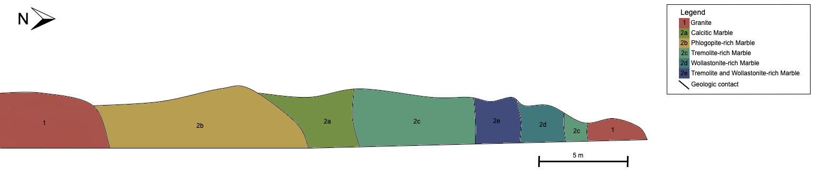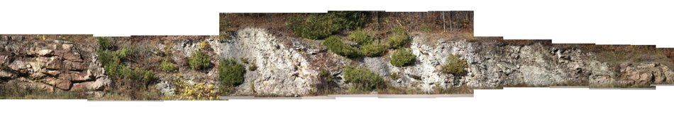
Figure 2: Our geological outcrop map with the identified rock units alongside the Gigamacro stitched outcrop photos (Earth 231, 2021)
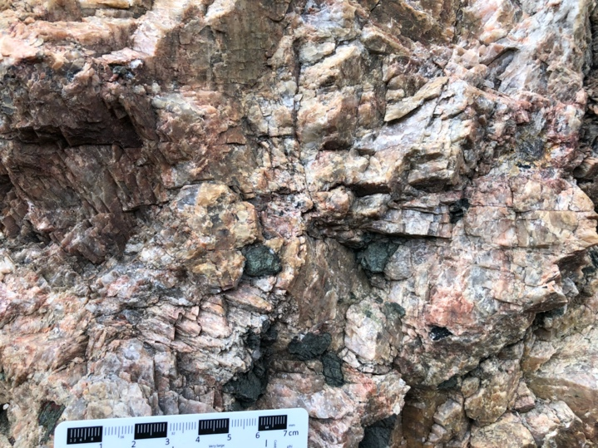
Figure 3: Granite rock unit with evident K-feldspar quartz and pyroxene identified due to their colour and physical properties such as hardness (Earth 231, 2021).

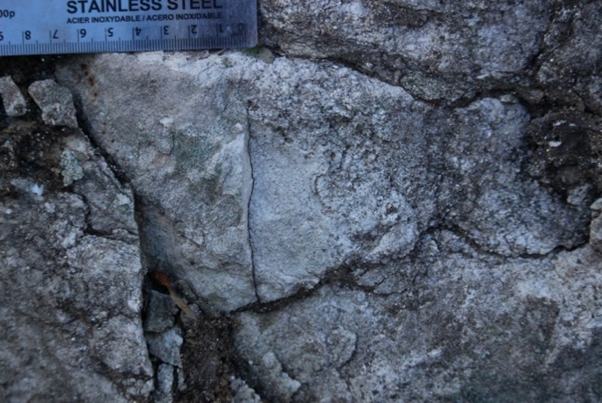
Figure 4: Mainly calcitic marble with low amounts of phlogopite. Identified as such due to strong reaction with dilute hydrochloric acid. Mineral identified as calcite has a low hardness of 3 and 3 cleavage planes at 75 degrees. (Earth 231, 2021)
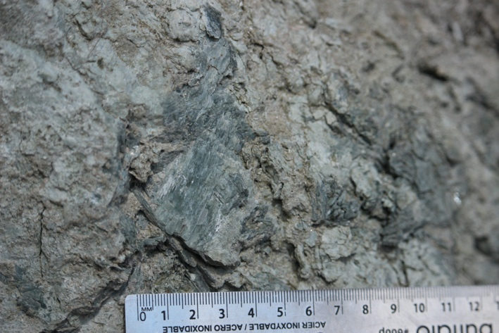
Figure 5: Tremolite, identified due to its fibrous lustre, hardness of 5.5, and 2 cleavage planes at 60 degrees and 120 degrees. (Earth 231, 2021)
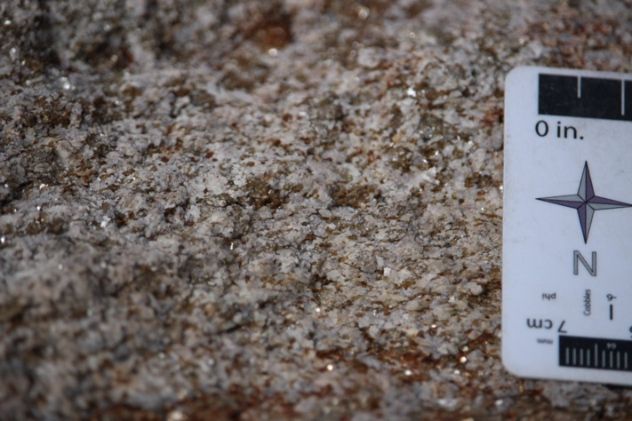
Figure 6: Wollastonite grains identified due to their two cleavage planes at 90 degrees, and hardness of 5. Also, some small phlogopite crystals with a hardness of 2.5 and perfect cleavage on one plane (Earth 231, 2021).
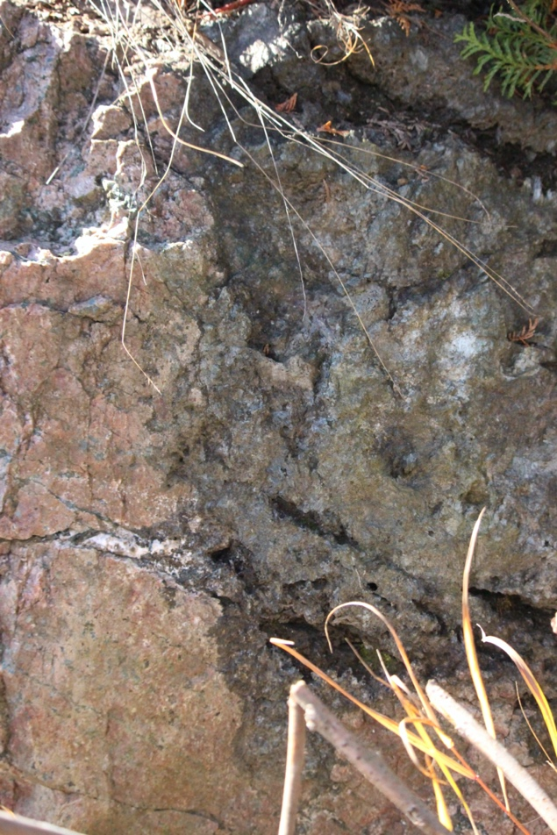
Figure 7: Contact between granite intrusion and marble, demonstrated by abrupt change in composition and color. (Earth 231, 2021)

